The Maldon Society
Blue Plaque walk
This walk is approximately 2 miles starting at The Maeldune Heritage Centre, Market Hill, Maldon which houses both The Maldon Society’s Photographic Archive and Oral History recordings.

Photographic archive – The Society maintains an archive of over 4000 photographs and drawings depicting life in Maldon during the 19th and 20th centuries. A touch screen display in the Heritage Centre enables visitors to browse the archive under various subject headings. These include People, Events, Gardens, Businesses, Towns and Villages and Heritage Buildings. Also included are videos of the history of Maldon Salt and the story behind the famous Maldon Millenium Embroidery.
Oral History recordings - Our collection of over eighty Oral History recordings relate the memories of many who grew up in Maldon and how life has changed. There are also stories from some who worked on barges, on local farms, and on the famous Maldon Millennium Embroidery. All of the recordings can also be found on our dedicated website www.maldonoralhistory.org

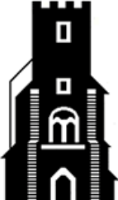
The Maeldune Heritage Centre is in the former Parish Church, a Grade II listed building, with churchyard and gardens outside for visitors to view. In the Centre there is a craft shop, with a selection of books, gifts, cards, and local produce.

The exhibition area, which changes regularly, displays work of local artists. The embroidery panels, which measure 42 feet in length, portray the life and times of the town in the thousand years since The Battle of Maldon 991 to 1991. One hundred volunteer embroideresses worked on the embroidery between 1987 and 1990. https://maelduneheritagecentre.org/
The walk
On leaving the Centre turn to the right and walk a little way down Market Hill and set back on the right you will see the United Reformed Church building.

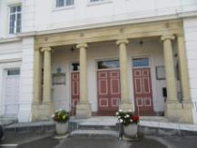
The portico was added in 1876 and the Blue Plaque can be seen on the wall of the church. The Reverend Joseph Billio, born in Hatfield Peverel in 1658, preached at the meeting house in 1696 to 400 Protestant Dissenters.
It was through the enthusiasm and fervour of his preaching that the phrase ‘like Billio’ may have come into the English language. His portrait hangs in the vestry.
Walking down Market Hill you will see on the opposite side of the road to Market Hill Gardens, the Union Workhouse (Blue Plaque) built with funds bequeathed by Dr Thomas Plume.
This building served as Maldon’s workhouse in 1834 and continued until 1873 when a new improved Union Workhouse in Spital Road was opened, which is now St Peter’s Hospital.
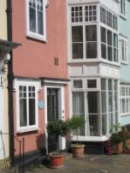
The original workhouse was intended only to take inmates of All Saints, St Peter’s and St Mary’s Parishes. In 1841, the Union Workhouse listed 80 males and 96 females, including 19 boys and 14 girls under 10 years, together with a master and his wife and son, and a schoolmaster and schoolmistress. The original building was converted into apartments.
Carefully crossing the road and walking up Cromwell Hill, at the top turn right, walk along Beeleigh Road with its unique cottages on the right-hand side. West Chase will be on the left side.
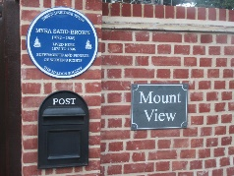
Walk a short distance up this unmade road to see a blue plaque recognising Myra Sadd Brown, a renowned suffragette born and raised in Maldon. https://en.wikipedia.org/wiki/Myra_Sadd_Brown

Walk to the end of the Chase turn left into London Road walking towards the Town Sign continue along the High Street to The Parish Church of All Saints with St Peter with its unique triangular tower. In this area, the original Moot Hall was sited (since demolished). Its courts and meeting rooms were transferred in 1576 to D’Arcy Tower – the present Moot Hall.
Past the horse trough, you will come to the Grade I listed Moot Hall (D’Arcy’s Tower with Black Plaque). This building is Maldon’s most historically important secular building.
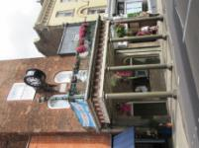
The building incorporates a police cell and exercise yard, 19th century court room, Council Chamber and panoramic rooftop views. The town clock with its five bell chimes was presented in 1881 by George Courtauld MP. (Tours of the Hall can be arranged)
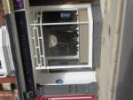
The buildings at 57 and 59 High Street (marked by a Blue Plaque) were home to Edward Bright senior, the ‘fat man at Maldon’. When Edward died in November 1750 he weighed well over 40 stone. His remains are interred in a vault in All Saints’ Church. He left three young children and his widow, Mary, expecting another. He is commemorated in the Maldon Embroidery and a replica of his enormous waistcoat can be seen in Maldon Museum in the Park, near Promenade Park Entrance. (J R Smith: The Borough of Maldon 1688-1800 a Golden Age 2013)
Continue to walk down the High Street and using the crossing continue until you came to Church House (opposite W H Smiths).
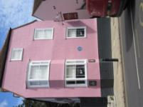
Here you will find a Blue Plaque on the wall of the house revealing this was the home of Edward Bright (junior), who like his father was a grocer. He was also a linen draper, candle maker and salt maker.
His final venture, in 1789-90, was the construction of a salt-water bath, on the banks of the Blackwater. He was active in local politics and, in 1779, became leader of Maldon’s Whigs. (J R Smith: The Borough of Maldon 1688-1800 a Golden Age 2013)
Continuing all the way down the High Street until opposite The Black Rabbit pub, turn left into North Street, walk down to where the road forks. Then continue walking straight ahead - you can see the jetty/river. A little way down on the left, Number 61 is the former home of John Howard (1849-1915) (Blue Plaque), a qualified naval architect and one of Maldon’s most famous barge builders.
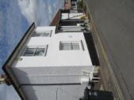
He was best known for his ‘stackie’ barges, known as ‘hay up and dung down’ because the barges were loaded with hay and straw at Maldon and returned with London horse muck for the clayfields by the River Blackwater.
Please retrace your steps to the junction, turn left and walk to the Hythe Quay to see the many Thames sailing barges moored there. Follow along the lane to the Promenade Park (entrance just along from the Hythe Quay). Edward Fitch, Mayor, gave much of the area covered by the present park to the Borough of Maldon in 1895 to provide a recreational park ‘for the well-being of the people’. He officially opened the park on 26th June 1895. We hope you have enjoyed your walk.
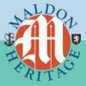
©The Maldon Society 2024. www.maldonsoc.org

